Spectral coherence: EURUSD and AUDUSD
Method 21 / daily log returns / Welch magnitude-squared coherence / Alpari D1 full available history

Study setup
Logical pair: EURUSD , AUDUSD
Broker symbols: EURUSD_i , AUDUSD_i
Snapshot: 2026-11-03_majors_alpari_D1
Timeframe: D1
Matched return window: 1999-01-05 to 2026-11-02 (UTC bar dates)
Matched return count n: 7201
Dropped unfinished last bar dated 2026-11-03 UTC after a tick-volume check against the prior complete day.
Welch: fs=1.0, nperseg=256, noverlap=128, window=hann, detrend=constant
Headline: gamma^2 nearest f=1/5; also 1/21 and 1/63
Complete matched rows (Excel): EURUSD-AUDUSD_Spectral_D1.xlsx
Complete matched rows (HTML table): EURUSD-AUDUSD_Spectral_D1_data.html

Method carried forward
Magnitude-squared spectral coherence gamma^2(f) measures shared linear power between matched daily log returns of close, ln(close_t / close_t-1), at each frequency f (cycles per day). Quotes are not inverted. Welch settings are frozen: fs=1, nperseg=256, noverlap=128, window=hann, detrend=constant. Headline is gamma^2 at the frequency bin nearest f=1/5 (five-day cycle from the formula sheet). Also reported: gamma^2 nearest f=1/21 and f=1/63, mean gamma^2 over the frequency grid, and phase of the cross-spectrum at the 1/5 bin. Coherence is unsigned (0 to 1); phase carries timing. Same-sample Pearson r is a side check only. This is not causation and not a trading signal.

Results (headline)
gamma^2 near 1/5: 0.396112
bin f (1/5): 0.199219
phase at 1/5 (rad): 0.206291
gamma^2 near 1/21: 0.360610
gamma^2 near 1/63: 0.402833
mean gamma^2: 0.337457
Pearson r: 0.556324

Target-frequency summary
period | target_f | f_bin | gamma2 | phase_rad
5 | 0.2 | 0.19921875 | 0.39611158 | 0.20629105
21 | 0.04761905 | 0.046875 | 0.36060959 | -0.11445807
63 | 0.01587302 | 0.015625 | 0.40283313 | 0.12174819

Conclusion
Headline gamma^2 near f=1/5 for EURUSD and AUDUSD: 0.3961 (bin f=0.199219, phase=0.2063 rad). At ~1/21: 0.3606; at ~1/63: 0.4028. Mean gamma^2 = 0.3375. Pearson r = 0.5563. This is frequency-domain linkage, not a trading signal.

Charts
Daily closes

Daily log returns

Spectral coherence gamma^2(f)
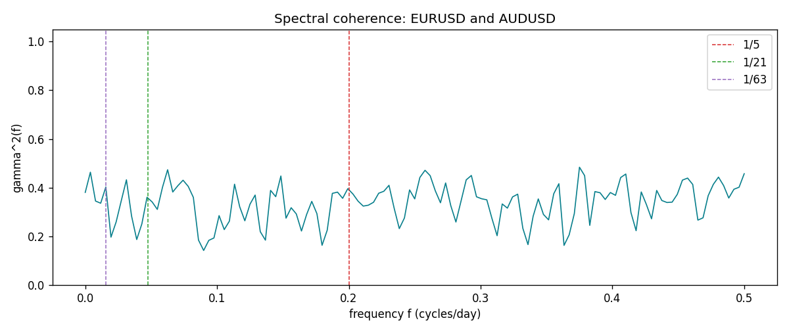

Data report
Matched rows and the coherence sheet are in the sibling Excel workbook named EURUSD-AUDUSD_Spectral_D1.xlsx. Embedding all rows as a Word table is impractical; this file holds column summaries and the first and last 15 matched rows.
Columns: time, EURUSD_open, AUDUSD_open, EURUSD_high, AUDUSD_high, EURUSD_low, AUDUSD_low, EURUSD_close, AUDUSD_close, EURUSD_tick_volume, AUDUSD_tick_volume, EURUSD_spread, AUDUSD_spread, EURUSD_real_volume, AUDUSD_real_volume, EURUSD_log_return, AUDUSD_log_return
Column summaries (matched calculation rows)
column | count | mean | std | min | 25% | 50% | 75% | max
EURUSD_open | 7201 | 1.1813268 | 0.15086382 | 0.8272 | 1.08608 | 1.16615 | 1.29393 | 1.5995
AUDUSD_open | 7201 | 0.75197127 | 0.13525779 | 0.4785 | 0.66105 | 0.73142 | 0.80912 | 1.10284
EURUSD_high | 7201 | 1.1864593 | 0.1514619 | 0.8326 | 1.0902 | 1.17128 | 1.29926 | 1.6038
AUDUSD_high | 7201 | 0.75602178 | 0.13581838 | 0.4878 | 0.6647 | 0.7349 | 0.81518 | 1.10795
EURUSD_low | 7201 | 1.1763142 | 0.15018707 | 0.8227 | 1.08202 | 1.16257 | 1.28834 | 1.5865
AUDUSD_low | 7201 | 0.74791431 | 0.13457219 | 0.4775 | 0.6577 | 0.72758 | 0.8042 | 1.0975
EURUSD_close | 7201 | 1.1813656 | 0.15083992 | 0.8267 | 1.08601 | 1.16617 | 1.29395 | 1.5997
AUDUSD_close | 7201 | 0.75202148 | 0.13524071 | 0.4786 | 0.6612 | 0.73175 | 0.80916 | 1.10169
EURUSD_tick_volume | 7201 | 103004.8 | 173409.64 | 469 | 9389 | 52708 | 99441 | 1471626
AUDUSD_tick_volume | 7201 | 77347.024 | 138135.9 | 109 | 5434 | 43320 | 71320 | 1234623
EURUSD_spread | 7201 | 19.396195 | 16.574381 | 0 | 8 | 12 | 30 | 50
AUDUSD_spread | 7201 | 30.819886 | 16.887485 | 0 | 13 | 30 | 50 | 50
EURUSD_real_volume | 7201 | 4.0238636e+10 | 1.6675367e+11 | 0 | 0 | 0 | 0 | 3.6149665e+12
AUDUSD_real_volume | 7201 | 5.2420906e+09 | 1.2538049e+11 | 0 | 0 | 0 | 0 | 3.811512e+12
EURUSD_log_return | 7201 | -7.54e-06 | 0.00580172 | -0.03123819 | -0.00324684 | 0 | 0.00325501 | 0.03433183
AUDUSD_log_return | 7201 | 2.459e-05 | 0.00754509 | -0.08602525 | -0.00385511 | 0.00028229 | 0.00415126 | 0.0806166
First 15 matched rows (selected columns)
time | EURUSD_log_return | AUDUSD_log_return
1999-01-05 | -0.0048360507 | -0.00080418179
1999-01-06 | -0.011547966 | 0.011836351
1999-01-07 | 0.0076280636 | 0.0088650256
1999-01-08 | -0.010902799 | 0.00031515916
1999-01-11 | -0.007103287 | 0.0072213815
1999-01-12 | 0.0045103728 | -0.0048608485
1999-01-13 | 0.010845346 | -0.0078902098
1999-01-14 | 0 | -0.002696916
1999-01-15 | -0.010153245 | 0.007123101
1999-01-18 | 0.0036256946 | 0.00094592471
1999-01-19 | -0.00017235436 | 0.0072225153
1999-01-20 | -0.0031939256 | 0.0012507819
1999-01-21 | 0.0030215416 | 0.00078094498
1999-01-22 | -0.0012075213 | -0.012252745
1999-01-25 | -0.0030251979 | -0.0039591468
Last 15 matched rows (selected columns)
time | EURUSD_log_return | AUDUSD_log_return
2026-10-13 | 0.0037402957 | 0.0035007712
2026-10-14 | -0.0037582255 | -0.0015193215
2026-10-15 | 0.0056053107 | -0.0075447063
2026-10-16 | 0.0017724895 | 0.0033906408
2026-10-19 | -0.0025394633 | 0.0050859986
2026-10-20 | 0.0023881672 | 0.0034620426
2026-10-21 | -0.00032046717 | 0.0036066384
2026-10-22 | -0.0015949606 | -0.0012672558
2026-10-23 | -0.001338521 | 0.0023765656
2026-10-26 | -0.0022706559 | -0.0032032829
2026-10-27 | -0.004152342 | 0.0016669876
2026-10-28 | 0.0022262927 | 0.0040915541
2026-10-29 | 0.0022571351 | -0.0040915541
2026-10-30 | -0.0011458446 | 0.0010102376
2026-11-02 | 0.002120569 | -0.0049184984
First 15 frequency bins
f | gamma2 | phase_rad | period_days
0 | 0.38058114 | 0 | inf
0.00390625 | 0.4635514 | -0.04355026 | 256
0.0078125 | 0.34514002 | 0.049969 | 128
0.01171875 | 0.33614257 | 0.06522147 | 85.333333
0.015625 | 0.40283313 | 0.12174819 | 64
0.01953125 | 0.19691356 | 0.18257696 | 51.2
0.0234375 | 0.25916736 | -0.28576896 | 42.666667
0.02734375 | 0.34656182 | -0.10378393 | 36.571429
0.03125 | 0.4323477 | -0.01692687 | 32
0.03515625 | 0.28337983 | 0.00021228 | 28.444444
0.0390625 | 0.18708832 | -0.06506246 | 25.6
0.04296875 | 0.25149566 | -0.3320082 | 23.272727
0.046875 | 0.36060959 | -0.11445807 | 21.333333
0.05078125 | 0.34135539 | 0.24564945 | 19.692308
0.0546875 | 0.31082359 | -0.10240144 | 18.285714

